**LEC. 2 Pharmacology Dr. Ihab Alkhalifa**

**Anxiolytic and Hypnotic Drugs**

**OVERVIEW**

Disorders involving anxiety are among the most common mental disorders.

Anxiety is an unpleasant state of tension, apprehension, or uneasiness ( like a fear that arises from either a known or an unknown source) with physical symptoms in severe anxiety as tachycardia, sweating, trembling, and palpitations) which involve sympathetic activation.

**Anxiety types**

1. **Mild Anxiety**  : Episodes of mild anxiety are common life experiences and do not warrant treatment.
2. **Sever , chronic, debilitating anxiety** may be treated with anti anxiety drugs (sometimes called anxiolytics) and/or some form of psychotherapy.

Because many antianxiety drugs also cause some sedation, they may be used clinically as both anxiolytic and hypnotic (sleepinducing) agents.

**Figure 9.1 summarizes the anxiolytic and hypnotic agents.**

Some antidepressants are also indicated for certain anxiety disorders; however, they are discussed with other antidepressants (see Chapter 10).



* **BENZODIAZEPINES**

Benzodiazepines are widely used anxiolytic drugs. They have largely replaced barbiturates and *meprobamate* in the treatment of anxiety and insomnia, because benzodiazepines are generally considered to be safer and more effective (Figure 9.2).

although benzodiazepines are commonly used, they are not necessarily the best choice for anxiety or insomnia.

Certain antidepressants with anxiolytic action, such as the selective serotonin reuptake inhibitors, are preferred in many cases, and nonbenzodiazepine hypnotics and antihistamines may be preferable for insomnia.



**Benzodiazepenes (BZD)**

**A-Class :** are a class of psychoactive drugs whose core chemical structure is the fusion of a benzene ring and a diazepine ring.

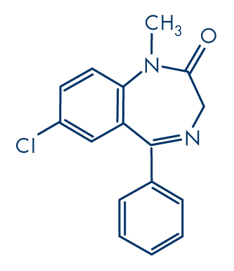 In 1977 benzodiazepines were globally the most prescribed medications. They are in the family of drugs commonly known as **minor tranquilizers.**

**B. Mechanism of action**

The targets for benzodiazepine actions are the γ-aminobutyric acid

(GABAA) receptors.

[Note: GABA is the major inhibitory neurotransmitter in the central nervous system (CNS).]

**Location & components of GABAA receptors**

The GABAA receptors are composed of a combination of five α, β, and γ subunits that span the postsynaptic membrane (Figure 9.3).

For each subunit, many subtypes exist (for example, there are six subtypes of the α subunit).

Binding of GABA to its receptor triggers an opening of the central ion

channel, allowing chloride through the pore (Figure 9.3).

The influx of chloride ions causes hyperpolarization of the neuron and decreases neurotransmission by inhibiting the formation of action potentials.

[Note: These binding sites are sometimes labeled “benzodiazepine

(BZ) receptors.” Common BZ receptor subtypes in the CNS

are designated as BZ1 or BZ2 depending on whether the binding site

includes an α1 or α2 subunit, respectively.]

**Benzodiazepines modulate GABA effects by binding to a specific,**

**high-affinity site (distinct from the GABA-binding site) located at the interface of the α subunit and the γ subunit on the GABAA receptor** (Figure 9.3).



Benzodiazepines increase the frequency of channel openings produced by GABA.

[Note: Binding of a benzodiazepine to its receptor site increases the affinity of GABA for the GABA-binding site (and vice versa).]

The clinical effects of the various benzodiazepines correlate well with the binding affinity of each drug for the GABA receptor–chloride ion channel complex.

**pharmacological Actions**

All benzodiazepines exhibit the following actions to some extent :

**1. Reduction of anxiety:** At low doses, the benzodiazepines are anxiolytic. They are thought to reduce anxiety by **selectively**

**enhancing GABAergic transmission in neurons having the α2 subunit in their GABAA receptors** , thereby inhibiting neuronal circuits in the limbic system of the brain.

**2. Sedative/hypnotic:** All benzodiazepines have sedative and calming

properties, and some can produce hypnosis (artificially produced sleep) at higher doses. **The hypnotic effects are mediated**

**by the α1-GABAA receptors.**

**3. Anterograde amnesia:** Temporary impairment of memory with use of the benzodiazepines is also **mediated by the α1-GABAA**

**receptors.** The ability to learn and form new memories is also impaired.

**4. Anticonvulsant:** Several benzodiazepines have anticonvulsant activity.

This effect is partially, although not completely, **mediated by α1-GABAA receptors.**

**5. Muscle relaxant :** At high doses, the benzodiazepines relax the spasticity of skeletal muscle, **probably by increasing presynaptic inhibition in the spinal cord, where the α2-GABAA receptors** are largely located.

**C. Pharmacokinetics**

**1. Absorption and distribution:** The benzodiazepines are lipophilic.

They are rapidly and completely absorbed after oral administration, distribute throughout the body and penetrate into the CNS.

**2. Duration of action:** The half-lives of the benzodiazepines are important clinically, because the duration of action may determine the therapeutic usefulness.

**The benzodiazepines can be thoroughly divided into :**

**short-, intermediate-, and long-acting groups** (Figure 9.4).

The longer-acting agents form active metabolites with long half-lives. However, with some benzodiazepines, the clinical duration of action does not correlate with the actual half-life (otherwise, a dose of *diazepam* could conceivably be given only every other day, given its active metabolites).

This may be due to receptor dissociation rates in the CNS and subsequent redistribution to fatty tissues and other areas.

**3. Fate ( Metabolism & elimination ) :** Most benzodiazepines, including **chlordiazepoxide and diazepam*,***are metabolized by the hepatic microsomal system to compounds that are also active. For these benzodiazepines, the apparent half-life of the drug represents the combined actions of the parent drug and its metabolites.

Drug effects are terminated not only by excretion but also by redistribution.

The benzodiazepines are excreted in the urine as glucuronides or oxidized metabolites.

**Q/ The benzodiazepines are not recommended for use during pregnancy & during breast feeding ?**

Since All benzodiazepines cross the placenta and may depress the CNS of the newborn if given before birth & in Nursing infants may also be exposed to the drugs in breast milk during breast feeding .

**D- Therapeutic uses & Adverse effects**

The individual benzodiazepines show small differences in their relative

**anxiolytic, anticonvulsant, and sedative properties**. However, the duration of action varies widely among this group, and pharmacokinetic considerations are often important in choosing one benzodiazepine over another.

**1. Anxiety disorders:** Benzodiazepines are effective for the treatment

of the anxiety symptoms of generalized anxiety disorder (GAD) & posttraumatic stress disorder

**Q / These drugs should be reserved for severe anxiety only and not used to manage the stress of everyday life ? why ?**

Because of their addiction potential, they should only be used for short periods of time.

**Classes of BZD duration of action**

* **The longer-acting agents, such as :**
* **Clonazepam [kloe-NAZ-e-pam]**
* **Diazepam [dye-AZ-e-pam]**
* **Flurazepam [flure-AZ-e-pam]**

Are often preferred in those patients with anxiety that may require prolonged treatment.

The antianxiety effects of the benzodiazepines are less subject to tolerance than the sedative and hypnotic effects.

Long-acting is rarely used, due to their extended half-life, which may result in excessive daytime sedation and accumulation of the drug, especially in the elderly.

**[Note: Tolerance (that is, decreased responsiveness to repeated doses of the drug) occurs when used for more than 1 to 2 weeks.**

Tolerance is associated with a decrease in GABA receptor density. Cross-tolerance exists between the benzodiazepines and *ethanol*.]

**For panic disorders, Alprazolam[al-PRAY-zoe-lam] is effective** for short- and long-term treatment, although it may cause withdrawal reactions in about 30% of patients.

**2. Sleep disorders:** A few of the benzodiazepines are useful as hypnotic agents. These agents decrease the latency to sleep onset and increase stage II of non–rapid eye movement (REM) sleep.

Both REM sleep and slow-wave sleep are decreased. In the treatment of insomnia, it is important to balance the sedative effect needed at bedtime with the residual sedation (“hangover”) upon awakening.

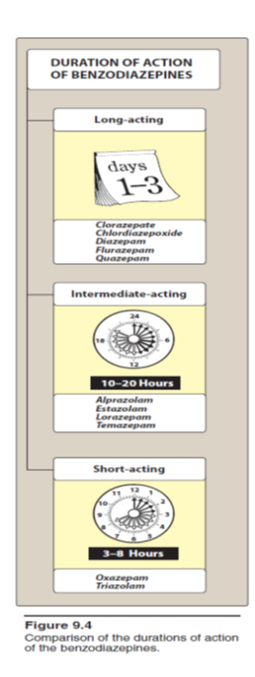**Commonly prescribed benzodiazepines for sleep disorders**

Include :

* **Intermediate-acting :**
* **Lorazepam [lor-AZ-e-pam]**
* **Temazepam[te-MAZ-e-pam]**
* **Alprazolam**
* **Short-acting :**
* **Triazolam**
* **Oxazepam**

**a. Temazepam :** This drug is useful in patients who experience frequent wakening. However, because the peak sedative effect occurs 1 to 3 hours after an oral dose,

**It should be given 1 to 2 hours before bedtime.**

**b. Triazolam :** Whereas temazepam is useful for insomnia caused by the inability to stay asleep, short-acting triazolamis effective in treating individuals who have difficulty in going to sleep.

**Q/ In general, hypnotics as BZD as Triazolam should be given for only a limited time, usually less than 2 to 4 weeks.? and it is best usedintermittently?**

A/ Since Tolerance frequently develops within a few days, and withdrawal

of the drug often results in rebound insomnia. Therefore, In general, hypnotics should be given for only a limited time, usually less than 2 to 4 weeks.

**3. Amnesia:** The shorter-acting agents are often employed as premedication for anxiety-provoking and unpleasant procedures, such as :

**Endoscopy , dental procedures, and angioplasty.**

They cause a form of conscious sedation, allowing the person to be receptive to instructions during these procedures.

**Midazolam**[mi-DAY-zoe-lam] is a benzodiazepine used to facilitate amnesia while causing sedation prior to anesthesia.

**4. Seizures: Clonazepam**is occasionally used as an adjunctive therapy

for certain types of seizures, whereas **lorazepam and diazepam are the drugs of choice in terminating status epilepticus (epilepsy ).**

**5- Alcohol withdrawal : Chlordiazepoxide , diazepam, lorazepam, and oxazepam**  are useful in the acute treatment of alcohol withdrawal and reduce the risk of withdrawal-related seizures.

**6. Muscular disorders: Diazepam**is useful in the treatment of skeletal Muscle spasms, such as occur in muscle strain, and in treating spasticity from degenerative disorders, such as multiple sclerosis and cerebral palsy.

**Adverse effects**

* Drowsiness and confusion are the most common side effects of the benzodiazepines.
* Ataxia occurs at high doses and precludes activities that require fine motor coordination, such as driving an automobile.
* Cognitive impairment (decreased long-term recall and retention of new knowledge) can occur with use of benzodiazepines.
* **Triazolam**often shows a rapid development of tolerance, early morning insomnia, and daytime anxiety, as well as amnesia and confusion.

**Dependence**

Psychological and physical dependence on benzodiazepines can

develop if high doses of the drugs are given for a prolonged period.

All benzodiazepines are controlled substances.

Abrupt discontinuation of the benzodiazepines results in withdrawal symptoms, including confusion, anxiety, agitation, restlessness, insomnia, tension, and (rarely) seizures.

Benzodiazepines with a short elimination half-life, such as

triazolam, induce more abrupt and severe withdrawal reactions than those seen with drugs that are slowly eliminated such as flurazepam .

**Precautions**

* Benzodiazepines should be used cautiously in patients with liver disease.
* These drugs should be avoided in patients with acute angle closure glaucoma.
* Alcohol and other CNS depressants enhance the sedative–hypnotic effects of the benzodiazepines.

Note/ Benzodiazepines are, however, considerably less dangerous than the older anxiolytic and hypnotic drugs. As a result, a drug overdose is seldom lethal unless other central depressants, such as alcohol, are taken concurrently.

**BENZODIAZEPINE ANTAGONIST**

**Flumazenil[floo-MAZ-eh-nill]**

**A-Class** : is a GABA receptor antagonist that can rapidly reverse the effects of benzodiazepines.

**B- Mechanism of action** : Flumazenil competitively antagonizes the actions of benzodiazepines in the CNS, not by displacing the agonist, but rather by occupying the benzodiazepine receptor site on the GABA-benzodiazepine receptor complex, when the agonist dissociates from it

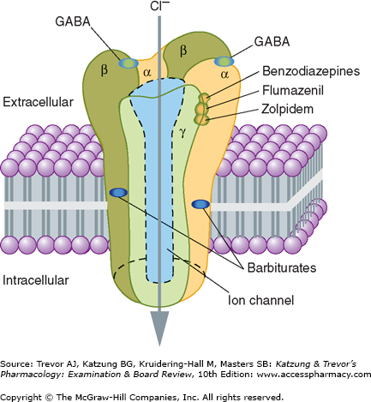**C-Pharmacokinetics** : The drug is available for intravenous (IV) administration only.

**Onset is rapid, but the duration is short, with a half-life of about 1 hour.**

**D- Adverse Effects** : Dizziness, nausea, vomiting, and agitation are the most common side effects.

Seizures may also result if the patient has a mixed ingestion with tricyclic antidepressants

**OTHER ANXIOLYTIC AGENTS**

**BARBITURATES**

Barbiturate is a drug that acts as a central nervous system depressant, and can therefore produce a **wide spectrum of effects, from mild sedation to total anesthesia. They are also effective as anxiolytics, hypnotics, and anticonvulsants.**

**Q/ They have largely been replaced by benzodiazepines in routine medical practice?**  **particularly in the treatment of anxiety and insomnia?**

**A/** due to the significant lower risk of overdose and the lack of an antidote for barbiturate overdose.

**Pharmacological actions :**

**Depression of CNS:** At low doses, the barbiturates produce

sedation (have a calming effect and reduce excitement).

At higher doses, the drugs cause hypnosis, followed by anesthesia (loss

of feeling or sensation), and, finally, coma and death.

Thus, any degree of depression of the CNS is possible, depending on the

dose .

**Note/** Barbiturates do not raise the pain threshold and have no analgesic properties. They may even exacerbate pain.

**Chronic use leads to tolerance.**

**2. Respiratory depression:** Barbiturates suppress the hypoxic and chemoreceptor response to CO2, and overdosage is followed by respiratory depression and death.

**Barbiturates**

1. **Class** : The name barbiturate originates from the fact that they are all chemical derivatives of barbituric acid .
2. **Mechanism of action :** barbiturates act as positive allosteric modulators, and at higher doses, as agonists of GABAA receptors. GABA is the principal inhibitory neurotransmitter in the mammalian central nervous system (CNS). Barbiturates bind to the GABAA receptor distinct from the benzodiazepine binding site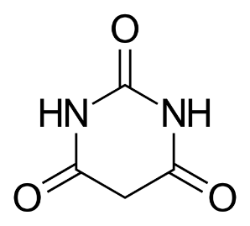  
   Barbiturates produce their pharmacological effects by increasing the duration of chloride ion channel opening at the GABAA receptor

The barbiturates were formerly the mainstay of treatment to sedate patients or to induce and maintain sleep.

The sedative–hypnotic action of the barbiturates is due to their interaction with GABAA receptors, which enhances GABAergic transmission BY 3 mechanisms :

1- Barbiturates potentiate GABA action on chloride entry into the neuron by prolonging the duration of the chloride channel openings.

2- In addition, barbiturates can block excitatory glutamate receptors.

3- Anesthetic concentrations of pentobarbital also block high-frequency sodium channels.

All of these molecular actions lead to decreased neuronal activity.

1. **Pharmacokinetics**

Barbiturates are well absorbed after oral administration and distribute throughout the body.

**Q/ All barbiturates redistribute from the brain to the splanchnic areas, to skeletal muscle, and, finally, to adipose tissue?**

Because of their high lipid solubility can pass easily through membranes

This movement is important in causing the short duration of action **of thiopental and similar short-acting derivatives.**

Barbiturates readily cross the placenta and can depress the fetus.

These agents are metabolized in the liver, and inactive metabolites are excreted in urine.

**Classes of Barbiturate Duration of Action**

Barbiturates are classified according to their duration of action (Figure 9.8). Acts within seconds and has a duration of action of about 30 minutes.

* **Long-acting** : Phenobarbital , has a duration of action greater than a day
* **Short-acting barbiturates** :

Pentobarbital [pentoe- BAR-bi-tal]

Secobarbital [see-koe-BAR-bi-tal]

Amobarbital [am-oh-BAR-bi-tal]

* **Ultra–short-acting thiopental** [thye-oh- PEN-tal]

**D-Therapeutic uses**

**1. Anesthesia:** The ultra–short-acting barbiturates, such as **thiopental,** have been used intravenously to induce anesthesia but have largely been replaced by other agents.

**2. Anticonvulsant: Phenobarbital**has specific anticonvulsant activity that is distinguished from the nonspecific CNS depression.

It is used in long-term management of tonic–clonic seizures. However,

*phenobarbital* can depress cognitive development in children and decrease cognitive performance in adults, **and it should be used only if other therapies have failed.**

Similarly, *phenobarbital* may be used for the treatment of refractory **status epilepticus ( type of epilepsy )** .

**3. Sedative/hypnotic:** Barbiturates have been used as mild sedatives to relieve anxiety, nervous tension, and insomnia. When used as hypnotics, they suppress REM sleep more than other stages.

**Q/ However, the use of barbiturates for insomnia is no longer generally accepted ?**

**A/**  due to their adverse effects and potential for tolerance.

Butalbital is commonly used in combination products (with acetaminophen and caffeine or aspirin and caffeine) as a sedative to assist in the management of tension-type or migraine headaches.

**Adverse effects**

Barbiturates cause drowsiness, impaired concentration, and mental and physical sluggishness (Figure 9.9).

The CNS depressant effects of barbiturates synergize with those of ethanol.

Hypnotic doses of barbiturates produce a drug “hangover” that may lead to impaired ability to function normally for many hours after waking.

Occasionally, nausea and dizziness occur. Barbiturates induce cytochrome P450 (CYP450) microsomal enzymes in the liver.

Therefore, chronic barbiturate administration diminishes the action of many drugs that are metabolized by the CYP450 system.

Barbiturates are contraindicated in patients with acute intermittent porphyria.

Abrupt withdrawal from barbiturates may cause tremors, anxiety, weakness, restlessness, nausea and vomiting, seizures, delirium, and cardiac arrest.

**OVERDOSE**

Severe depression of respiration is coupled with central cardiovascular

depression and results in a shock-like condition with shallow, infrequent breathing.

Treatment includes supportive care and gastric decontamination for recent ingestions.

**DEATH**

Withdrawal is much more severe than that associated with opiates and can result in death.

**Death may also result from overdose.**

**OTHER HYPNOTIC AGENTS**

**Non-benzodiazepine drugs**, **zolpidem, zaleplon, and ramelton**

* **Zolpidem**

**A-Class**  : The hypnotic zolpidem[ZOL-pi-dem] is not structurally related to benzodiazepines .

1. **Mechanism of action** : but it selectively binds to the benzodiazepine receptor subtype BZ1.
2. **Pharmcokinetics** : Zolpidem is rapidly absorbed from the gastrointestinal (GI) tract, and it has a rapid onset of action and short elimination half-life (about 2 to 3 hours). *Zolpidem* undergoes

Note/ hepatic oxidation by the CYP450 system to inactive products.

Thus, drugs such as rifampin*,* which induce this enzyme system, shorten

the half-life of zolpidem*,* and drugs that inhibit the CYP3A4 isoenzyme

may increase the half-life.

1. **Therapeutic uses** : It provides a hypnotic effect for approximately 5 hours (Figure 9.10).

A lingual spray and an extended-release formulation are also available.

A sublingual tablet formulation may be used for middle-of-the-night awakening.]

**Adverse effects** of zolpidem include :

Nightmares, agitation, anterograde amnesia, and daytime drowsiness.

**Q/ Non-BZD drugs zolpidem, zaleplon, and eszopiclone*,*are often the preferred hypnotics over BZD ? WHY?**

A/ **This may be due to** :

1-their relative selectivity for the BZ1 receptor

2- Do not significantly alter the various sleep stages

3- It shows few withdrawal effects

4-exhibits minimal rebound insomnia, and little tolerance occurs with prolonged use.

**Note/ Zolpidem has no anticonvulsant or muscle-relaxing properties.**

* **Zaleplon**

Zaleplon [ZAL-e-plon] is an oral nonbenzodiazepine hypnotic similar to zolpidem; however, zaleplon causes fewer residual effects on psychomotor and cognitive function compared to zolpidem or the benzodiazepines.

This may be due to its rapid elimination, with a half-life of approximately 1 hour. The drug is metabolized by CYP3A4.

* **Ramelteon**

Ramelteon, marketed as Rozerem by Takeda Pharmaceuticals North America, is a sleep agent that selectively binds to the MT1 and MT2 receptors in the It however does not appear to speed the onset of sleep or the amount of sleep a person gets.

It is approved by the U.S. Food and Drug Administration (FDA) for long-term use.

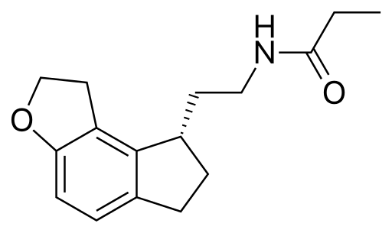

**A-Class** : Ramelteon [ram-EL-tee-on]

is a selective agonist at the Melatonin receptors

( MT1 and MT2 subtypes ) in the suprachiasmatic nucleus (SCN) of the brain , instead of binding to GABAA receptors, such as with drugs like zolpidem.

Melatonin is a hormone secreted by the pineal gland that helps to maintain the circadian rhythm underlying the normal sleep–wake cycle , so it is called **( sleep hormone )**  Ramelteon does not show any appreciable binding to GABAA receptors, which are associated with anxiolytic, myorelaxant, and amnesic effects.

**B- Mechanism of action** : Stimulation of MT1 and MT2 receptors subtypes of melatonin receptors , pineal gland secretes melatonin hormon ( sleep hormon) that helps to maintain the circadian rhythm underlying the normal sleep–wake cycle, by ramelteon is thought to induce and promote sleep.

**Indications & adverse effects** : *Ramelteon* is indicated for the treatment of insomnia characterized by difficulty falling asleep (increased sleep latency).

**Q/ Ramelteoncan be administered for long term to induce sleep**

**A/** sinceIt has minimal potential for abuse, with no evidence of dependence or withdrawal effects has been observed.

**Common adverse effects** **of ramelteon**include :

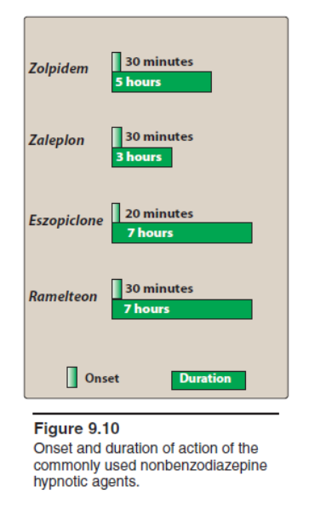dizziness, fatigue, and somnolence.

**Ramelteon may also increase prolactin levels.**

**Antihistamines**

Some antihistamines with sedating properties, such as **diphenhydramine,**

**Hydroxyzine , and doxylamine** *,* are effective in treating mild types of situational insomnia. However, they have undesirable side effects (such as anticholinergic effects) that make them less useful than the benzodiazepines and the nonbenzodiazepines.

Some sedative antihistamines are marketed in numerous over-the-counter products.

**Antidepressants**

The use of sedating antidepressants with strong antihistamine profiles has been ongoing for decades. **Doxepin [DOX-e-pin**], an older tricyclic agent with SNRI mechanisms of antidepressant and anxiolytic action, was recently approved at low doses for the management of insomnia. Other antidepressants, such as **trazodone [TRAZ-ohdone], mirtazapine [mir-TAZ-a-pine],** and other older tricyclic antidepressants with strong antihistamine properties are used off-label for the treatment of insomnia (see Chapter Antidepressant drugs ).

Many antidepressants are effective in the treatment of chronic anxiety disorders and should be considered as **first-line agents, especially in patients with concerns for addiction or dependence.**

* **Selective serotonin reuptake inhibitors (SSRIs, such as escitalopram or paroxetine)**
* **Serotonin/Norepinephrine Reuptake Inhibitors** (SNRIs), such as **venlafaxine or duloxetine**) may be used alone or prescribed in combination with a low dose of a benzodiazepine during the first weeks of treatment

After 4 to 6 weeks, when the antidepressant begins to produce an anxiolytic effect, the benzodiazepine dose can be tapered.

**Note/ SSRIs and SNRIs have a lower potential for physical dependence than the benzodiazepines and have become first-line treatment for generalized anxiety disorders (GAD**).

The efficacy of these drugs for GAD is most likely a class effect.

Thus, the choice among these antidepressants should be based upon side effects and cost.

Long-term use of antidepressants and benzodiazepines for anxiety disorders is often required to maintain ongoing benefit and prevent relapse.

* **Escitalopram or Paroxetine**

1. Class : Selective serotonin reuptake inhibitors (SSRIs)
2. Mechanism of action : SSRIs are believed to increase the extracellular level of the neurotransmitter serotonin by limiting its reabsorption into the presynaptic cell, increasing the level of serotonin in the synaptic cleft available to bind to the postsynaptic receptor.
3. Pharmacokinetics : Paroxetine is well-absorbed following oral administration. It has an absolute bioavailability of about 50%, When taken orally, it achieves maximum concentration in about 6-10 hours and reaches steady-state in 7-14 days.

Less than 2% of an oral dose is excreted in urine unchanged.

**Paroxetine is a mechanism-based inhibitor of Hepatic CYP 450**

1. Therapeutic uses & Adverse effect : Paroxetine is primarily used to treat major depressive disorder

* **SNRIs : Venlafaxine or Duloxetine (**see Chapter Antidepressant drugs**)**

**Buspirone [byoo-SPYE-rone]**

**Buspirone** : is an anxiolytic drug that is primarily used to treat generalized anxiety disorder (GAD) . It is also commonly used to augment antidepressants in the treatment of major depressive disorder.

Unlike most anxiolytics, the pharmacology of buspirone is not related to that of benzodiazepines, barbiturates (it is not a GABA receptor agonist), and so buspirone **does not carry the risk of physical dependence and withdrawal symptoms for which those drug classes are known**.

Buspirone is not considered to be a drug-of-abuse, is safer in overdose than traditional anxiolytics, and is significantly less impairing at therapeutic doses.

**Buspirone [byoo-SPYE-rone]**

1. **CLASS**: is in a class of medications called anti-anxiety medications. Buspirone is not related to other anti-anxiety medications, such as benzodiazepines, barbiturates or other sedative/ anxiolytic drugs
2. **Mechanism of action** : The actions of buspirone appear to be mediated by serotonin (5-HT1A) receptors, although it also displays some affinity for D2 dopamine receptors and 5-HT2A serotonin receptors.
3. **Pharmacokinetics**  : It has a slow onset of action and is not effective for short-term treatment of acute anxiety states.
4. **Therapeutic uses & Adverse effects** : Buspirone is approved in the United States by the Food and Drug Administration (FDA) for the short- or long-term treatment of anxiety disorders or can also be used for the short-term relief of the symptoms of anxiety.

Useful for the chronic treatment of GAD and has an efficacy comparable to that of the benzodiazepines.

The frequency of adverse effects is low, with the most common effects being headaches, dizziness, nervousness, nausea, and light-headedness. Sedation and psychomotor and cognitive dysfunction are minimal, and dependence is unlikely.

Buspirone does not potentiate the CNS depression of alcohol. In addition, buspirone lacks the anticonvulsant and muscle-relaxant properties of the benzodiazepines.

**Summary of the therapeutic disadvantages and advantagesof some of the anxiolytic and hypnotic drugs.**