**Lab.8 chlorosulfonation of acetanilide**

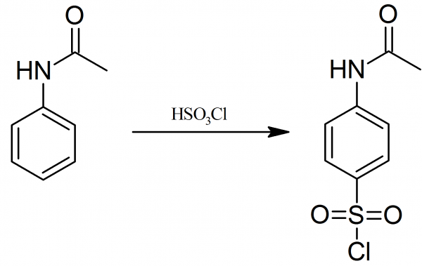

chlorosulfonation of acetanilide results in production an intermediate p-acetamidobenzenesulfonylchloride. In the present investigation it was found that proper mixture of acetanilide and chlorosulfonic acid is required for a good quality of intermediate.

Acetanilide will be used as the starting material.  Reaction of acetanilide with chlorosulfonic acid provides p-acetaminobenzene sulfonyl chloride through *an electrophilic aromatic substitution*.  The sulfonyl chloride reacts readily with ammonia in a reaction that is mechanistically analogous to the nucleophilic acyl substitution reaction of carbonyl compounds.

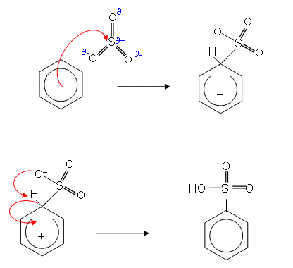

Materials and equipment:

1. Acetanilide
2. Chlorosulfonic acid
3. P- acetamido benzene sulfonyl chloride

Procedure :

1. Weigh out 5.0g of acetanilide and dispense it into a 125 ml  Erlenmeyer flask .  Add a magnetic stir bar to the flask.  Clamp  the flask to a ring stand and set it in an ice bath resting on a hot plate/stirrer.  Position the mouth of the flask under a burette containing the chlorosulfonic acid . See Figure bellow .  Turn on the stirrer and slowly open the stopcock of the burette to dispense 12.5 ml of chlorosulfonic acid, drop by drop, into the Erlenmeyer flask. *(Warning:  Chlorosulfonic acid is extremely corrosive and toxic.  Gloves must be worn!)*Continue stirring the reaction mixture as much as possible until all the chlorosulfonic acid is added .

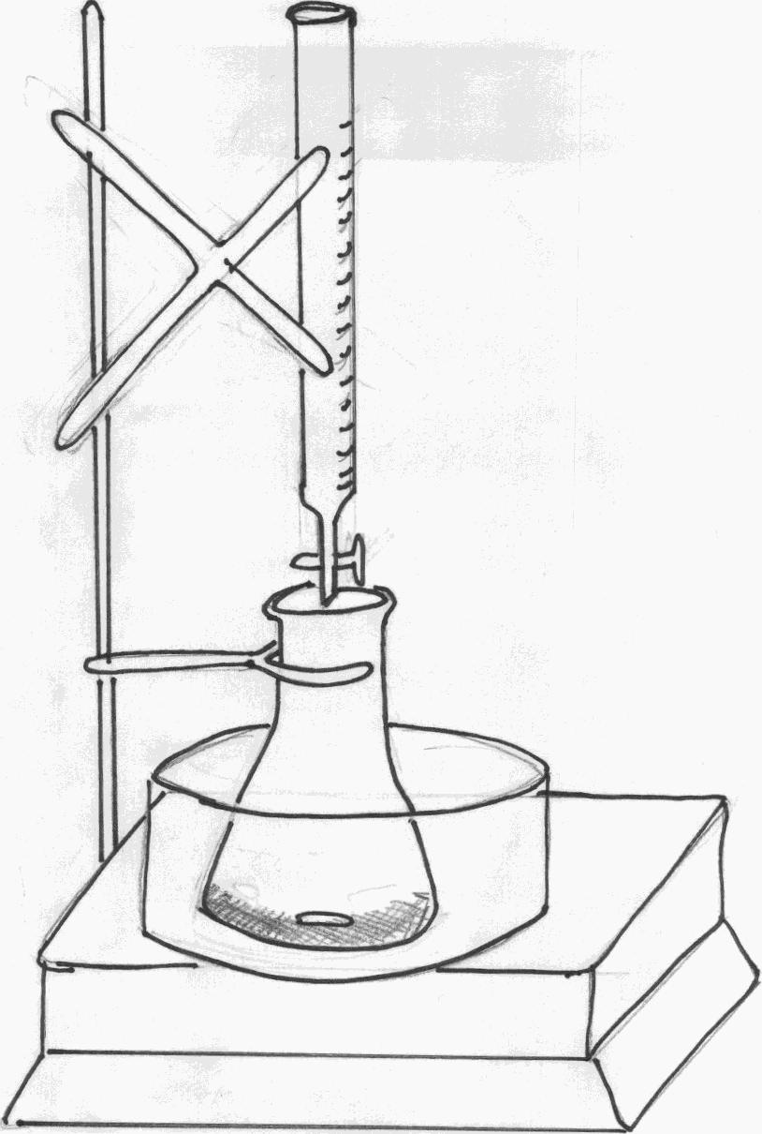

1. While the chlorosulfonic acid is being added to the flask, clamp a water trap to a second ring stand.  When the addition of 12.5ml of chlorosulfonic acid is complete, connect the reaction flask to a vacuum trap filled with ~30ml of water,  keeping both flasks clamped to their respective ring stands.  The glass tube inserted into the vacuum trap should be positioned ~1 inch above the surface of the water.   Insert the rubber stopper at the end of the trap hose into the mouth of the reaction flask. Remove the ice bath (if it is plastic) from the reaction flask and place it under the trap flask.  Place a new, glass water bath under the reaction flask. If the ice bath is glass, leave it in place and place a new ice bath under the flask used as the trap. See Figure bellow.  Continue stirring the reaction mixture and unclamp the reaction flask if necessary to swirl its contents.  Stir until all of the acetanilide is dissolved

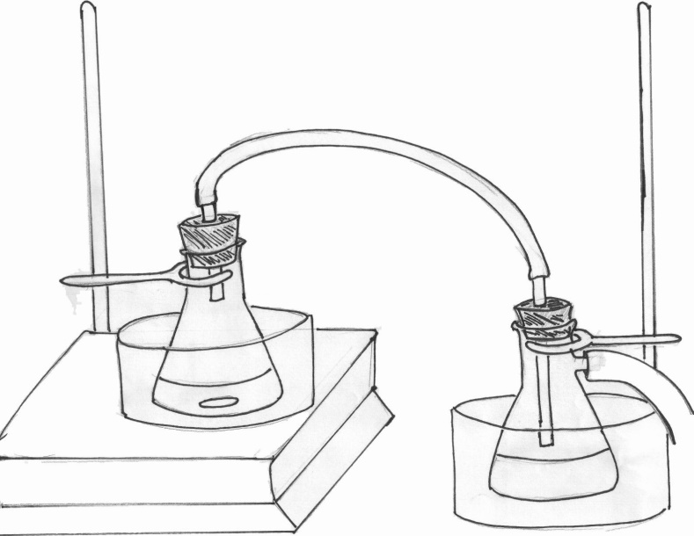

3-After the acetanilide is completely dissolved, turn on the water bath to just below boiling and heat the reaction mixture for 10 minutes.  After the heating is complete, a brown-yellow oil should remain.  Add ~75ml of ice to a 150ml beaker.  Disconnect the trap from the reaction flask containing the oil product.  Using a disposable glass pipette, add all the oil to the beaker containing the ice, drop by drop.  As the oil comes in contact with the ice, a white precipitate should form. Add an additional 10ml of cold, distilled water to the beaker and swirl the mixture until all the ice is melted.  Separate the solid from the mixture using vacuum filtration.

1. Wash the solid twice with ~20 ml of cold, distilled water.  The solid is p-acetaminobenzenesulfonyl chlorid