Lab.7

The general reaction :

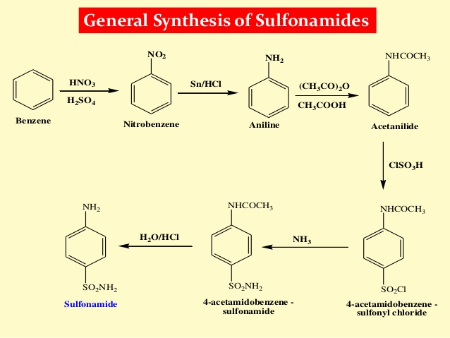

**preparation of acetanilide from aniline or acetylation of aniline**

Acetylation.

Compounds of the type ROH (alcohols and phenols), and also compounds of the type RNH2 and R2NH (primary and secondary amines) can be directly acetylated, the reactive H atom being replaced by the acetyl radical, -COCH3.

Primary and secondary amines give acetyl derivatives of the type RNHCOCH3 and R2NCOCH3 respectively, which can be regarded as mono-and di-substituted derivatives of acetamide, H2NCOCH3.

The chief method of acetylation of amines :

**Heating with a mixture of acetic anhydride and acetic acid.**

If a primary or secondary amine is heated with glacial acetic acid, the

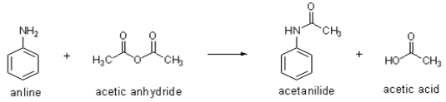

corresponding acetyl derivative is produced, but the process is often extremely slow. If, however, the acetic acid is mixed with acetic anhydride, rapid acetylation usually results.

One disadvantage of using acetic anhydride is that with primary amines, traces of the diacetyl compound, RN(COCH3)2, may be formed: the chances of this secondary acetylation are, however, usually remote, and recrystallisation from an aqueous solvent will generally hydrolyse the diacetyl derivative rapidly back to the mono-acetyl compound

Acetanilideis an odourless [solid](https://en.wikipedia.org/wiki/Solid) chemical of leaf or flake-like appearance. It is also known as *N*-phenylacetamide, acetanil, or acetanilide

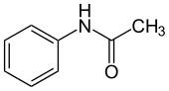

Acetanilide was the first [aniline](https://en.wikipedia.org/wiki/Aniline) derivative found to possess [analgesic](https://en.wikipedia.org/wiki/Analgesic) as well as [antipyretic](https://en.wikipedia.org/wiki/Antipyretic) properties, and was quickly introduced into medical practice under the names of Antifebrin in 1886. But its (apparent) unacceptable toxic effects, the most alarming being [cyanosis](https://en.wikipedia.org/wiki/Cyanosis) due to [methemoglobinemia](https://en.wikipedia.org/wiki/Methemoglobinemia" \o "Methemoglobinemia) and ultimately liver and kidney damage, prompted the search for supposedly less toxic aniline derivatives such as [phenacetin](https://en.wikipedia.org/wiki/Phenacetin" \o "Phenacetin). After several conflicting results over the ensuing fifty years, it was established in 1948 that acetanilide was mostly [metabolized](https://en.wikipedia.org/wiki/Metabolism) to [paracetamol](https://en.wikipedia.org/wiki/Paracetamol" \o "Paracetamol) (acetaminophen) in the human body, and that it was this metabolite that was responsible for the analgesic and antipyretic properties. The observed methemoglobinemia after acetanilide administration was ascribed to the small proportion of acetanilide that is [hydrolyzed](https://en.wikipedia.org/wiki/Hydrolysis) to aniline in the body. Acetanilide is no longer used as a drug in its own right, although the success of its metabolite – paracetamol (acetaminophen) – is well known (although it is itself [toxic in excessive amounts](https://en.wikipedia.org/wiki/Paracetamol_toxicity)).

**Mechanism of action**

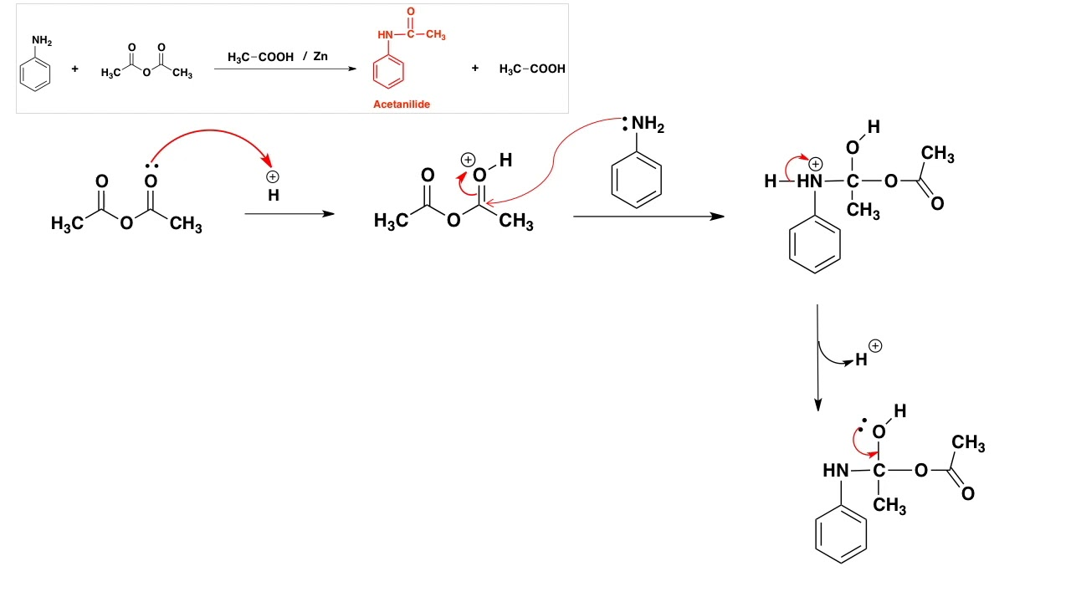

**Required:**

* Acetic acid/anhydride mixture, 20 ml
* Aniline 10 ml.

**Procedure**

1. Add 20 ml. of a mixture of equal volumes of acetic anhydride and glacial acetic acid to 10 ml. (10.3 g.) of aniline contained in a 150 ml. conical flask.
2. Fit a reflux water-condenser to the flask, and boil the mixture gently for 10 minutes.
3. Then pour the hot liquid into 200 ml. of cold water, stirring the latter well
4. during the addition. The acetanilide rapidly crystallises. Filter at the pump, and wash the crude acetanilide well with water.
5. Recrystallise from about 60 ml. of a mixture of one volume of acetic acid and two volumes of water:
6. filter off the colourless crystals at the pump, again wash thoroughly with water, drain, and dry. M.p. 113°.

**calculations :**

since the aniline is the limiting reagent , the yield should be calculated from its amount taken .

* M.,wt of aniline = 93 g / mole
* M.wt of acetanilide = 135 g / mole

Theoretical yield :

1mole of aniline forms = 1 mole of acetanilide

93 g/mole of aniline form = 135 g/mole

Therefore , 10.3 g ( 10ml ) aniline = x g

X = (10.3 x 135 ) / 93

X= 14.95 g

Yield = practical wt. / theoretical wt x 100%