Lab.6

preparation of aniline ( reduction of nitrobenzene )

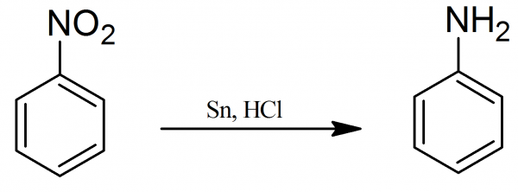

**preparation of aniline ( reduction of nitrobenzene )**

Stage 1: conversion of nitrobenzene into phenylammonium ions

Nitrobenzene is reduced to phenylammonium ions using a mixture of tin and concentrated hydrochloric acid. The mixture is heated under reflux in a boiling water bath for about half an hour.

Under the acidic conditions, rather than getting phenylamine directly, you instead get phenylammonium ions formed. The lone pair on the nitrogen in the phenylamine picks up a hydrogen ion from the acid.

The electron-half-equation for this reaction is:

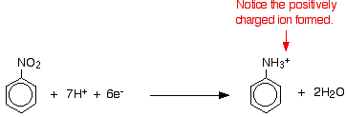

**Stage 2: conversion of the phenylammonium ions into phenylamine**

All you need to do is to remove the hydrogen ion from the -NH3+ group.

Sodium hydroxide solution is added to the product of the first stage of the reaction.

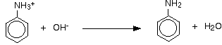

The phenylamine is finally separated from this mixture. The separation is long, tedious and potentially dangerous - involving steam distillation, solvent extraction and a final distillation.