Lab.5

**2-preparation of aniline ( reduction of nitrobenzene )**

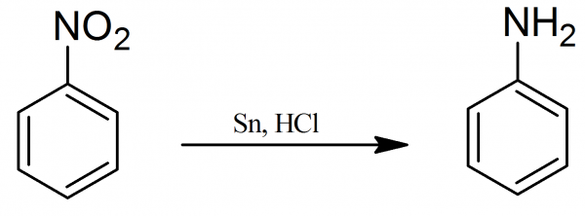

The conversion is done in two main stages:

**Stage 1: conversion of nitrobenzene into phenylammonium ions**

Nitrobenzene is reduced to phenylammonium ions using a mixture of tin and concentrated hydrochloric acid. The mixture is heated under reflux in a boiling water bath for about half an hour.

Under the acidic conditions, rather than getting phenylamine directly, you instead get phenylammonium ions formed. The lone pair on the nitrogen in the phenylamine picks up a hydrogen ion from the acid.

The electron-half-equation for this reaction is:

https://www.chemguide.co.uk/organicprops/aniline/padding.gif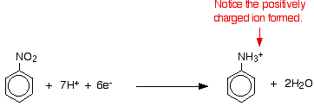

The nitrobenzene has been reduced by gaining electrons in the presence of the acid.

The electrons come from the tin, which forms both tin(II) and tin(IV) ions.

https://www.chemguide.co.uk/organicprops/aniline/padding.gifhttps://www.chemguide.co.uk/organicprops/aniline/sneqn1.gif

https://www.chemguide.co.uk/organicprops/aniline/padding.gifhttps://www.chemguide.co.uk/organicprops/aniline/sneqn2.gif

**Stage 2: conversion of the phenylammonium ions into phenylamine**

All you need to do is to remove the hydrogen ion from the -NH3+ group.

Sodium hydroxide solution is added to the product of the first stage of the reaction.

https://www.chemguide.co.uk/organicprops/aniline/padding.gif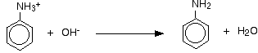

The phenylamine is formed together with a complicated mixture of tin compounds from reactions between the sodium hydroxide solution and the complex tin ions formed during the first stage.

The phenylamine is finally separated from this mixture. The separation is long, tedious and potentially dangerous - involving steam distillation, solvent extraction and a final distillation.

Preparation of aniline

1-In a 1 liter round-bottomed flask a mixture of 50 grams of granulated tin and 24.6 grams (or 20.5 ml) of [nitrobenzene](http://www.prepchem.com/synthesis-of-nitrobenzene/) are placed.

2- The flask is connected to a reflux condenser and through a dropping funnel in the course of about 30 minutes 110 ml of concentrated hydrochloric acid are added in the following manner.; About 10% of the HCl is added and the mixture is stirred for a few minutes.

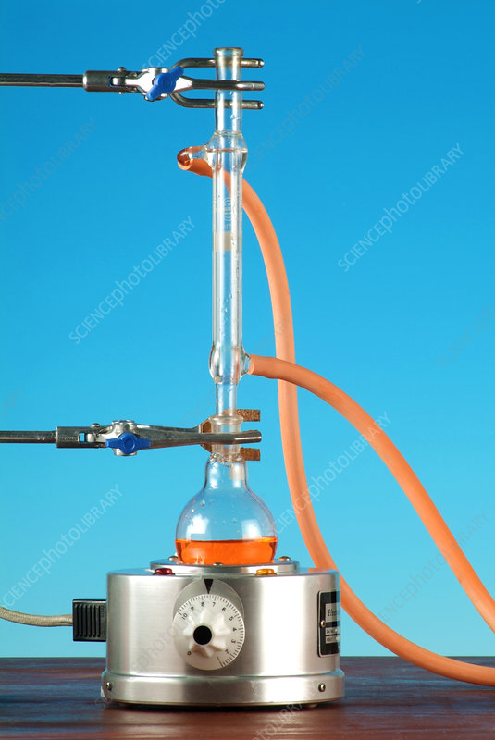

3- The mixture becomes warm and the reaction becomes vigorous. however, no more acid should be added. The reaction should be allowed to proceed slowly, but when there is danger of the boiling becoming too violent the flask is immersed for a time in a cold water to moderate, without completely suppressing, the reaction. When the boiling begins a second portion of about 10 ml of HCl are added. During the addition, the reaction is kept under control but maintained at a good rate by the action of the fresh portion of hydrochloric acid. Furthermore,

4- the mixture should be shaken well in order to bring the [nitrobenzene](http://www.prepchem.com/synthesis-of-nitrobenzene/) layer completely into reaction. After the acid is all added the mixture is heated for about one-half hour to complete the reduction.

5- The end of the reaction can be recognized from the disappearance of the odor of [nitrobenzene](http://www.prepchem.com/synthesis-of-nitrobenzene/) and by diluting a few drops of the solution with water, when a perfectly clear solution should be obtained.

6- When the reaction is complete, the flask is cooled and a solution of 75 grams of sodium hydroxide dissolved in 150 ml of water are added. The hydroxides of tin which are first precipitated should all dissolve and the solution should be distinctly alkaline. The content of the reduction reaction is transferred in a steam distillation apparatus and [aniline](http://www.prepchem.com/synthesis-of-aniline/) is removed by steam distillation.