College of Pharmacy
Fourth year. Clinical Pharmacy
Respiratory disorders

Asthma
Asthma is defined by the Global Initiative for Asthma (GINA) as a heterogeneous disease usually characterized by chronic airway inflammation. It is defined by a history of respiratory symptoms such as wheezing, shortness of breath, chest tightness, and cough that vary over time and in intensity, together with variable expiratory airflow limitation.

Pathophysiology
1-There is a variable degree of airflow obstruction. In acute inflammation, inhaled allergens in allergic patients cause activation of inflammatory cells (mast cells, neutrophils and macrophages)

2-After rapid activation, inflammatory cells release proinflammatory mediators such as histamine and eicosanoids that induce contraction of airway smooth muscle (bronchospasm), mucus secretion, edema, and exudation of plasma in the airways.

Clinical presentation

A-Chronic asthma
Signs and symptoms include episodes of shortness of breath, chest tightness, dry coughing (particularly at night), wheezing, or a whistling sound when breathing. These often occur with exercise but may occur spontaneously or in association with known allergens.

B-Acute severe asthma
1-Uncontrolled asthma can progress to an acute state. Patients may be anxious in acute distress and complain of severe dyspnea, shortness of breath, chest tightness, or burning. They may be able to say only a few words with each breath. Symptoms are unresponsive to usual measures (ie, SABAs).

2-Signs include dry, hacking cough; tachypnea; tachycardia; pallor or cyanosis; and hyperinflated chest with intercostal and supraclavicular retractions.

Diagnosis

A-Chronic asthma
1-Diagnosis is made primarily by history and confirmatory spirometry.

2-Spirometry demonstrates obstruction (forced expiratory volume in 1 second [FEV1]/forced vital capacity [FVC] <80%) with reversibility after inhaled β2-agonist administration.

B-Acute severe asthma
1-Peak expiratory flows (PEF) and FEV1 are <40% of normal predicted values. Pulse oximetry reveals decreased arterial oxygen and O2 saturations.

2-Arterial blood gases may reveal metabolic acidosis and low partial pressure of oxygen (PaO2).

Treatment

Goals of Treatment: The GINA long-term goals for asthma management include:
(1) achieve good control of symptoms and maintain normal activity levels.
(2) minimize future risk of exacerbations, and side effects.

For acute severe asthma, the primary goal is prevention of life-threatening asthma by early recognition of signs of deterioration and providing rapid treatment.

Nonpharmacologic Therapy
1-Patient education is mandatory to improve medication adherence, self-management skills, and use of healthcare services.

2-Routine PEF monitoring is generally recommended only for patients with severe asthma or poor symptom perception.

3-Avoidance of known allergenic triggers can improve symptoms, and reduce medication use. Smokers should be encouraged to quit.

4-In acute asthma exacerbations, initiate oxygen therapy.

5-Correct dehydration if present.

Pharmacologic Therapy

General Approach
1-Figure 1 summarizes GINA recommendations for initial treatment in adults and adolescents with asthma (further reading).

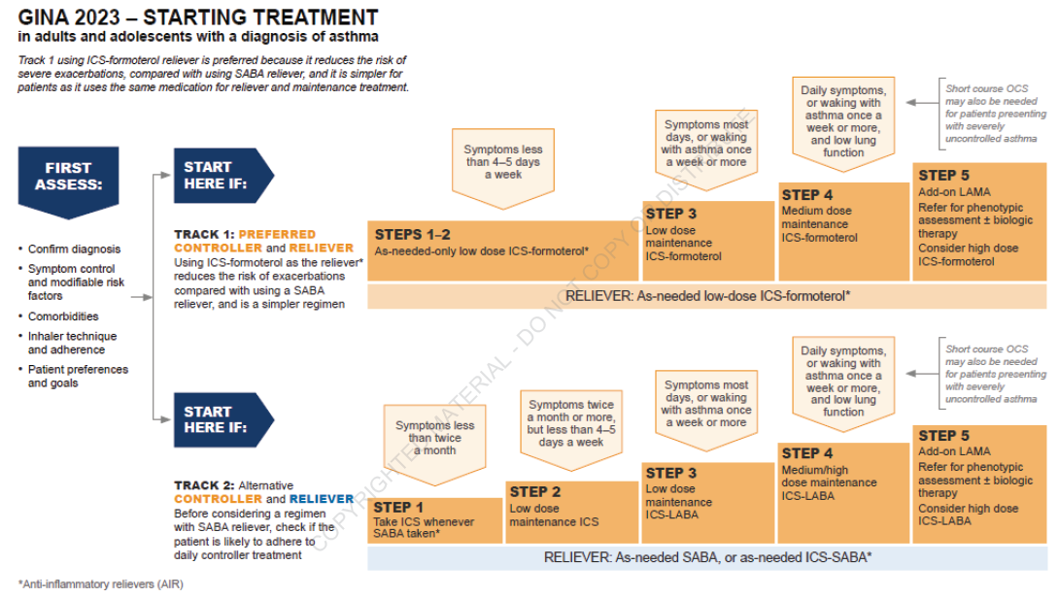
Figure 1: GINA recommendations for initial treatment in adults and adolescents
2-Despite the addition of inhaled corticosteroid-short acting β2 agonist (ICS-SABA) reliever in track 2, GINA track 1 with as-needed ICS- formoterol remains the preferred treatment for adults and adolescents ⁽²⁾.

[Single Maintenance and Reliever Therapy (SMART) also called Maintenance and Reliever Therapy (MART) in GINA guidelines: SMART therapy with ICS-formoterol significantly reduces the risk of severe exacerbation compared with using a SABA reliever, with similar symptom control] ⁽²⁾.

3-Depending on the inflammatory phenotype (e.g. allergic asthma, eosinophilic asthma) and other clinical features, add-on treatment for severe asthma include long acting muscarinic antagonist (LAMA), leukotriene receptor antagonists (LTRA), and biologic agents ⁽²⁾.

4-Low-dose maintenance oral corticosteroid (OCS) should be considered only as a last resort if no other options are available, because of their long-term side effects ⁽²⁾.

5-Once good asthma control has been achieved and maintained for 2-3 months, consider stepping down gradually to find the patient's lowest treatment that controls both symptoms and exacerbations ⁽²⁾.

6-The primary therapy of acute exacerbations includes inhaled SABAs and (depending on severity) systemic corticosteroids, inhaled ipratropium, intravenous (IV) magnesium sulfate, and oxygen. Treatments are typically administered concurrently to facilitate rapid improvement.

β2-Agonists
1- SABAs (eg, albuterol) are the treatment of first choice for managing acute severe asthma. A SABA is also indicated for as needed treatment of intermittent episodes of bronchospasm (e.g., exercise induced bronchospasm).

2-Aerosol administration enhances bronchoselectivity and provides more rapid response than systemic administration.

3-Two long-acting β2-agonists (LABAs), formoterol and salmeterol, provide bronchodilation for 12 hours or longer and are dosed twice daily. When combined with an ICS, formoterol may be dosed on a daily and as needed basis (thus, more frequently than twice daily).

Corticosteroids
1-ICS are the preferred long-term control therapy for persistent asthma because of potency and consistent effectiveness; they are the only therapy shown to reduce risk of dying from asthma.

2-Response to ICS is delayed.

3-Systemic toxicity of ICS is minimal with low-to-moderate doses, but risk of systemic effects increases with high doses (e.g., growth suppression in children, osteoporosis, cataracts, dermal thinning, adrenal insufficiency).

4-Local adverse effects include dose-dependent oropharyngeal candidiasis and dysphonia, which can be reduced by using a spacer device.

5-Systemic corticosteroids are indicated in all patients with acute severe asthma not responding completely to initial inhaled β2-agonist administration and should be administered within 1 hour of presentation.

6-IV therapy offers no advantage over oral administration except in patients unable to take oral medications.

Anticholinergics
1-Anticholinergics reverse cholinergic mediated bronchoconstriction and are effective bronchodilators in asthma.

2-Ipratropium bromide is useful as adjunctive therapy in acute severe asthma not completely responsive to SABA alone.

3-Patients with persistent asthma who are intolerant to short acting β2agonists may be prescribed ipratropium for rescue inhaler use.

4-Tiotropium bromide is a long acting inhaled anticholinergics with a duration of 24 hours. Tiotropium may be considered an add on therapy in patients whose asthma is not well controlled with ICS and LABA combination therapy.

Leukotriene Modifiers
1-Zafirlukast and montelukast are oral leukotriene receptor antagonists (LTRA) that reduce the proinflammatory and bronchoconstriction effects of leukotriene D4.

2-They are less effective than ICS, and they are less effective than LABAs when added to ICS. They are not used to treat acute exacerbations and must be taken on a regular basis, even during symptom-free periods.

3-Use of montelukast and zafirlukast has fallen out of favor due to increased observance of unusual adverse effects and modest therapeutic efficacy.

4-Because of reports of adverse neuropsychiatric events especially within a few weeks of starting therapy, monitor patients for signs of irritability, aggressiveness, and sleep disturbances; suicidality has also been reported rarely.

5-There have been reports of fatal hepatic failure associated with zafirlukast.

6-Zileuton is a 5-lipoxygenase inhibitor; its use is limited due to potential for elevated hepatic enzymes and inhibition of metabolism of drugs metabolized by CYP3A4 (eg, theophylline, warfarin).

Biologic Agents
1-These agents target the IgE pathway (Omalizumab) or (IL-4, IL-13) (Dupilumab), and IL-5 pathways (Mepolizumab, Benralizumab and reslizumab).

A-Omalizumab is approved for treatment of allergic asthma.

B-Mepolizumab, Benralizumab, Dupilumab and reslizumab are indicated for patients with an “eosinophilic phenotype”.

Magnesium Sulfate
1-Magnesium sulfate is a moderately potent bronchodilator, producing relaxation of smooth muscle by blocking calcium ion influx into smooth muscles; it may also have anti-inflammatory effects.

2-For patients with severe asthma exacerbations, a single 2 g IV infusion may reduce hospital admissions

3-Adverse effects include hypotension, facial flushing, sweating, depressed deep tendon reflexes, hypothermia, and CNS and respiratory depression.

Methylxanthines
1-Methylxanthines are rarely used today because of the high risk of severe life-threatening
toxicity, numerous drug interactions, and decreased efficacy compared with ICS, LABAs, and biologics.

2-Theophylline is available for oral and IV administration. Theophylline dosing requires monitoring of serum concentrations for both efficacy and toxicity, including seizures and death.

3-In addition, theophylline is eliminated primarily by metabolism via the hepatic CYP P450 microsomal enzymes, and drug interactions affecting metabolism significantly affect blood concentrations.

Evaluation of therapeutic outcomes
1-All patients on inhaled drugs should have their inhalation technique evaluated monthly initially and then every 3–6 months.

2-After initiation of anti-inflammatory therapy or increase in dosage, most patients should experience decreased symptoms within 1–2 weeks and achieve maximum improvement within 4–8 weeks.

Reference
1-Joseph T. DiPiro, Robert L. Pharmacotherapy: A Pathophysiologic Approach,
12th Edition. 2023.
2-GINA guideline. 2023.

Further reading

Table 1: Initial asthma-treatment recommended options for adults and adolescents ⁽²⁾.
