Ministry of Higher Education Class: 3rd stage Lecture (2)
And Scientific Research Subject: Hematology.
Al-Rasheed University College 2022/ 2023
Department of medical laboratory Assist. Prof. Dr.: Abbas Atiya Hammoudi
Techniques
The Blood System
Introduction
The 5 liters of blood of a 70 kg person constitute about 7% of the body's total weight. The blood flows from the heart into arteries, then to capillaries, and returns to the heart through veins.
Blood is composed of 52–62% liquid plasma and 38–48% cells. The plasma is mostly water (91.5%) and acts as a solvent for transporting other materials (7%) protein [consisting of albumins (54%), globulins (38%), and fibrinogen (7%). Blood is slightly alkaline (pH = 7.40 ± .05) and a tad heavier than water (density = 1.057 ±.009).
All blood cells are manufactured by stem cells, which live mainly in the bone marrow, via a process called hematopoiesis. The stem cells produce hemocytoblasts that differentiate into the precursors for all the different types of blood cells. Hemocytoblasts mature into three types of blood cells: erythrocytes (red blood cells or RBCs), leukocytes (white blood cells or WBCs), and thrombocytes (platelets).
The leukocytes are further subdivided into granulocytes (containing large granules in the cytoplasm) and agranulocytes (without granules). The granulocytes consist of neutrophils (55–70%), eosinophils (1–3%), and basophils (0.5–1.0%). The agranulocytes are lymphocytes (consisting of B cells and T cells) and monocytes. Lymphocytes circulate in the blood and lymph systems, and make their home in the lymphoid organs.
1
All of the major cells in the blood system are illustrated below.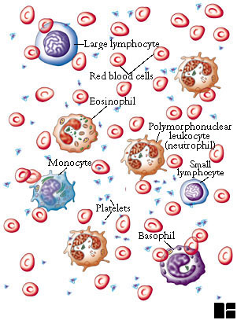
There are 5000–10,000 WBCs per mm³ and they live 5-9 days. About 2,400,000 RBCs are produced each second and each lives for about 120 days (They migrate to the spleen to die. Once there, that organ scavenges usable proteins from their carcasses). A healthy male has about 5 million RBCs per mm³, whereas females have a bit fewer than 5 million.

2

Normal Adult Blood Cell Counts
Red Blood Cells |  | 5.0*10⁶/mm³
Platelets |  | 2.5*10⁵/mm³
Leukocytes |  | 7.3*10³/mm³
 | Neutrophil |  | 50-70%
 | Lymphocyte |  | 20-40%
 | Monocyte |  | 1-6%
 | Eosinophil |  | 1-3%
 | Basophil |  | <1%
The RBCs is responsible for the usual ABO blood grouping, among other things. The grouping is characterized by the presence or absence of A and/or B antigens on the surface of the RBCs. Blood type AB means both antigens are present and type O means both antigens are absent. Type A blood has A antigens and type B blood has B antigens.
Some of the blood, but not red blood cells (RBCs), is pushed through the capillaries into the interstitial fluid.
Hematopoiesis
Simply, hematopoiesis is the process through which the body manufactures blood cells. It begins early in the development of an embryo, well before birth, and continues for the life of an individual.
Hematopoiesis in the embryo
Sometimes called primitive hematopoiesis, hematopoiesis in the embryo produces only red blood cells that can provide developing organs with oxygen. At this stage in development, the yolk sac, which nourishes the embryo until the placenta is fully developed, controls hematopoiesis.
As the embryo continues to develop, the hematopoiesis process moves to the liver, the spleen, and bone marrow, and begins producing other types of blood cells.
In adults, hematopoiesis of red blood cells and platelets occurs primarily in the
3
bone marrow. In infants and children, it may also continue in the spleen and liver.
The lymph system, particularly the spleen, lymph nodes, and thymus, produces a type of white blood cell called lymphocytes. Tissue in the liver, spleen, lymph nodes and some other organs produce another type of white blood cells, called monocytes.
The blood is made up of more than 10 different cell types. Each of these cell types falls into one of three broad categories:
- Red blood cells (erythrocytes): These transport oxygen and hemoglobin throughout the body.
2. White blood cells (leukocytes): These support the immune system. There are several different types of white blood cells:
- Lymphocytes: Including T cells and B cells, which help fight some viruses and tumors.
- Neutrophils: These help fight bacterial and fungal infections.
- Eosinophils: These play a role in the inflammatory response, and help fight some parasites.
- Basophils: These release the histamines necessary for the inflammatory response.
- Macrophages: These engulf and digest debris, including bacteria.
3. Platelets (thrombocytes): These help the blood to clot.
Current research endorses a theory of hematopoiesis called the monophyletic theory. This theory says that one type of stem cell produces all types of blood cells.

4
Erythropoiesis
Erythropoiesis (from Greek 'erythro' meaning "red" and 'poiesis' "to make") is the process which produces red blood cells (erythrocytes), which is the development from erythropoietic stem cell for mature red blood cell.
On average, the body produces an astounding 2.5 billion red cells/kg/day. Erythrocytes arise from a complex line of cells, and their rate of production is tightly regulated to ensure adequate but not excessive numbers of red blood cells are produced.
Sites of Erythropoiesis
The site of erythropoiesis changes throughout life. In the very early foetus, it occurs in the yolk sac. From 2 – 5 months’ gestation it occurs in the liver and spleen before finally establishing in the bone marrow from about 5 months’ gestation.
In children, erythropoiesis can occur in the bone marrow of most bones. However, in adults, it only occurs in the bone marrow of the vertebrae, ribs, sternum, sacrum, pelvis and proximal femur.
When erythropoiesis is inadequate in the bone marrow, this can trigger extramedullary haematopoiesis – i.e. haematopoiesis occurring outside the marrow. This is commonly seen in haemoglobulinopathies, in particular thalassaemias and myelofibrosis.
Stages of Erythropoiesis
The production of all blood cells begins with the haemocytoblast, a multipotent haematopoietic stem cell. Haemocytoblasts have the greatest powers of self-renewal of any adult cell. They are found in the bone marrow and can be mobilised into the circulating blood when needed.

5

Some haemocytoblasts differentiate into common myeloid progenitor cells, which go on to produce erythrocytes, as well as mast cells, megakaryocytes and myeloblasts
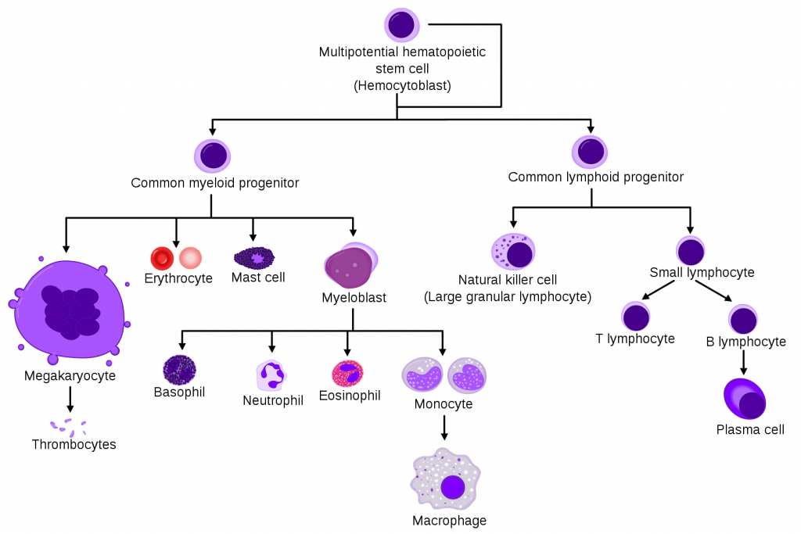
Fig 1 – The cell line of erythropoeisis
The process by which common myeloid progenitor cells become fully mature red blood cells involves several stages.
First, they become normoblasts (aka eryhthroblasts), which are normally present in the bone marrow only.
Secondly, they lose some organelles and their nucleus as they mature into reticulocytes, which can be thought of as immature red blood cells. Some of these are released into the peripheral circulation.

6
Finally, reticulocytes lose their remaining organelles as they mature into erythrocytes, which are fully mature red blood cells. These normally survive for around 120 days. During this maturation process, there is nuclear
extrusion – i.e. mature erythrocytes have no nucleus. Nucleated red blood cells
present in a sample of bone marrow can indicates the release of incompletely
developed cells. This can occur in pathology such as thalassaemia, severe
anaemia or haematological malignancy.
Regulation of Erythropoiesis
Erythropoiesis is driven mainly by the hormone erythropoietin (EPO), which is a glycoprotein cytokine.
EPO is secreted by the kidney. It is constantly secreted at a low level, sufficient for the normal regulation of erythropoiesis. However, if the erythrocyte level becomes inadequate, the blood becomes relatively hypoxic. When there is a reduced partial pressure of oxygen (pO2) in the kidney, this is detected by the renal interstitial peritubular cells.
In response, there is a surge in EPO production, which acts in the bone marrow to stimulate increased red blood cell production. This causes haemoglobin levels to increase, subsequently causing the pO2 to rise and therefore EPO levels to fall. The feedback loop is complete.
Morphology of RBCs

The foundation of laboratory hematologic diagnosis is the complete blood count and review of the peripheral smear. In patients with anemia, the peripheral smear permits interpretation of diagnostically significant red blood cell (RBC) findings. These include assessment of RBC shape, size, color, inclusions, and arrangement. Abnormalities of RBC shape and other

7

RBC features can provide key information in establishing a differential diagnosis.

Normally, a red cell has a round form, shaped like a disc, well-haemoglobinised cytoplasmic rim with a central pallor covering inner third of the red cell. Deviations in morphology (size, shape, colour, contents/inclusion or distribution) may be associated or perhaps diagnostic of disease entities.

Evaluation and interpretation of red blood cell (RBC) morphology is an important component of a complete blood count (CBC). RBC morphology may provide important diagnostic information regarding the underlying cause of anemia and systemic disease.

Normal, mature RBCs are biconcave, disc-shaped, anuclear cells measuring approximately 7-8 microns in diameter on a peripheral blood smear with an internal volume of 80-100 femtoliters (fL). The term used to describe RBCs of normal size is "normocytic." When judging red cell size on a blood smear, the classic rule of thumb is to compare them to the nucleus of a small normal lymphocyte, which has an approximate diameter of 8 microns (note that this method is not foolproof, as red cells that have less than the normal hemoglobin content tend to flatten out more on a slide and may appear larger than they actually are).

On a Wright-stained peripheral blood smear, normal mature RBCs that contain sufficient hemoglobin have a red-orange appearance with a central pallor (lighter area inside of the cell) no larger than 3 microns in diameter. The term used to describe RBCs of normal color is "normochromic." Normocytic, normochromic cells as they appear on a Wright-stained peripheral blood smear are shown in the image on the right.

Normal functioning RBCs survive for approximately 120 days in the peripheral blood circulation before being removed by the liver or spleen.

8

Under normal circumstances, the body produces enough RBCs each day to offset the removal of senescent (old) cells.

RBCs must deform in order to pass through the smallest blood vessels. The deformability of normal RBCs comes from their flexible membranes.

Certain disease states can alter normal RBC characteristics. This course will describe various RBC morphologic changes and correlate the changes with specific disease states or conditions.

Normal mature red blood cells:

Normal mature RBC are biconcave, round discs that are about 6 - 8 m in diameter, which is only slightly smaller than the normal small mature lymphocyte (about 6-10m in diameter). The term used to indicate red blood cells of normal size and shape is normocytic. The term used to indicate a normal color or central pallor (i.e., normal hemoglobin content) is normochromic.

Immature red blood cells in normal peripheral blood:

Polychromatophilic erythrocytes are enucleated slightly immature red blood cells that may be found in small numbers (0.5-1.5%) in normal peripheral blood. They have a faint bluish-grey tint and are usually slightly larger than a mature RBC. When present in increased numbers, a comment is made as a part of the “diff” report.

Immature nucleated red blood cells (NRBC) are not normally seen in adult blood. However, they may be seen normally in newborns and abnormally in disease. When present, the number observed per 100 WBC is noted and used to correct the total WBC count.

The cell membrane of RBCs

The cell membrane is composed of proteins and lipids, and this structure provides properties essential for physiological cell function such

9

as deformability and stability while traversing the circulatory system and specifically the capillary network.

Membrane composition

Red blood cells are deformable, flexible, are able to adhere to other cells, and are able to interface with immune cells. Their membrane plays many roles in this. These functions are highly dependent on the membrane composition. The red blood cell membrane is composed of 3 layers: the glycocalyx on the exterior, which is rich in carbohydrates; the lipid bilayer which contains many transmembrane proteins, besides its lipidic main constituents; and the membrane skeleton, a structural network of proteins located on the inner surface of the lipid bilayer. Half of the membrane mass in human and most mammalian red blood cells are proteins. The other half are lipids, namely phospholipids and cholesterol.

Erythrocyte Metabolism

RBC metabolism includes the glycolytic pathways producing both energy (as adenosine 5′- triphosphate, or (ATP) and oxidation-reduction intermediates that support oxygen transport and membrane flexibility

RBC metabolism is entirely dependent on anaerobic metabolism via glycolysis and the pentose phosphate pathway to produce adenosine triphosphate (ATP) for cellular processes, and reduced glutathione for oxidative free radical scavenging.

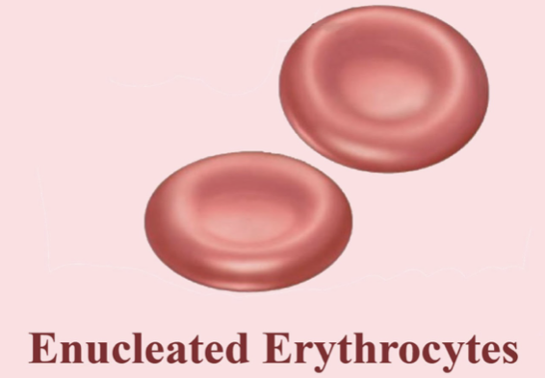

10

